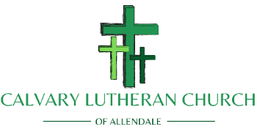
2021 ANNUAL MEETING
Voters Response Card
As you follow along live or on a recorded version on Calvary’s Facebook “Videos” @ https://www.facebook.com/Calvary-Lutheran-Church-of-Allendale-299349926873305/ please take a moment to answer the questions below as a responsive vote. You may return your vote via email to office@calvaryluth.org or drop it in the office personally. Voting will be suspended on March 13th, 2021.
- Call to Order / Recognition of Quorum
Circle One
(Agree) (Disagree)
- Reading of the Mission Statement: To teach and display the love of Christ by connecting with people of all walks of life through worship, discipleship, and outreach to our community.
- Opening Litany and Prayer
- Old Business:
  - Approval of Minutes
    - Annual Meeting – February 10, 2020
Circle One
(Agree) (Disagree)

  - Treasurer’s Report 2020
Circle One
(Agree) (Disagree)

  - Acceptance of 2020 Reports
    - 2020 Council President
    - Standing Committee Reports
      - Investment (Endowment) Report
      - Outreach
      - Stewardship
      - Property
      - Caring
      - Christian Education
      - Worship & Music
Circle One
(Agree) (Disagree)

- New Business
  - Annual Meeting for Elections – February 21st 2021

Nominees
Bruce Heitman = Council President (2nd Term)
Jim Holland = Vice President
Mercedes Caes = Treasurer
Jerry DelGatto = Secretary
Torri Gooden (1st Term)
Marilyn Strauch
Alma Costello
Kristine Nooney
Christa Metri (2nd Term)
Circle One
(Agree) (Disagree) (Exceptions, please list below)

  - Call Committee Update
  - Other

- Adjournment with The Lord’s Prayer

